More Important Conference Information

TRANSPORTATION:
We encourage the use of public transportation (A, C, D, F, N, Q, R, E, and #1 subways are all nearby). If you are driving, 12 hours of parking is available for $16 (with a sticker from Calvary Baptist Church) at Central Parking/SP+ (51 West 56th Street, between 6th and 5th Avenues – on the left just before Benihana Restaurant).

PLEASE NOTE: this Conference is not designed for children and no child care will be available that day.

Today’s Equipping Staff

Robert Casteline – Associate Pastor, Central Baptist Church

Christopher Gardner – Pastor, Metropolitan Baptist Church

Michael Herbert – Pastor, Fellowship Bible Church

Daniel Mann – Teacher and Writer

Randel Stubbs – Fiduciary Control Analyst

Lawrence Taylor – Pastor, Kenilworth Baptist Church

Nelson Thermitus – Dean, Evangelical Bible Institute

Michael Velardo – Dean, New York School of the Bible

Tanya Velardo – Children’s Ministry Dir, Renaissance Ch.

David Watson – President, NY Institute for Biblical Studies


***********************************************************
Workshop Descriptions are available on line.

You can also register on line.
www.nysb.nyc

Register by mail: New York School of the Bible
123 West 57th Street, New York, NY 10019
Please make check payable to “NYSB”
212-975-0170 X123 or nysb@cbcnyc.org

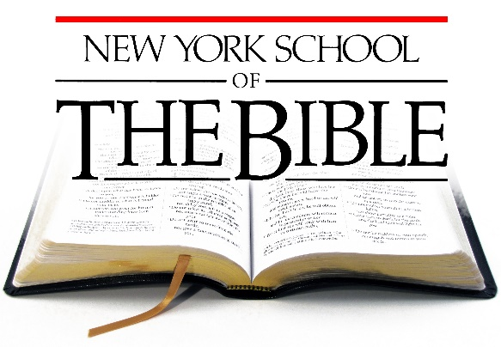

Teaching God’s Word
Equipping God’s People

Teaching and Equipping Conference

Saturday, March 25, 2017
Calvary Baptist Church
123 West 57th Street, New York, NY 10019

Registration opens at 8:00 a.m.
First session at 9:00 a.m. – Closing prayer at 4:00 p.m.

FREE BOOK AUTHORED BY ONE OF OUR FACULTY WILL BE GIVEN TO ALL ATTENDEES AT 4:00 P.M.

God has blessed New York School of the Bible with many special, dedicated, and knowledgeable faculty members. Both general sessions and all of our workshops will be conducted by members of our own
NYSB faculty team.

NYSB is a ministry of Calvary Baptist Church.
NYSB is affiliated with Lancaster Bible College.
The Day’s Path to Teaching and Equipping

“And he gave …teachers to equip the saints
for the work of ministry…”
Ephesians 4:11 and 12

Welcome and Worship 9:00 a.m.

Let’s Get Started 9:20 a.m.
Embracing God’s Passion for Diversity
Tanya Velardo

Workshop Session “A” 10:15 a.m. – 11:15 a.m.

Workshop Session “B” 11:30 a.m. – 12:30 p.m.

Lunch Break 12:30 p.m. – 1:30 p.m.
Boxed lunch included

Workshop Session “C” 1:45 p.m. – 2:45 p.m.

Final Challenge 3:00 p.m. – 3:40 p.m.
Is There A Pediatric Orthopedic in the House?
Rev. Dr. David Watson

Equipped: Now Go and Serve 3:45 p.m. – 4:00 p.m.

Important Conference Information

REGISTRATION:
$60 on line, in person, or postmarked by January 31st and $70 after that date. Registration includes 2 general sessions, 3 workshops, lunch, conference notebook, and free book!

Equipping Workshops
If you take all three workshops from one track and you decide to pursue an NYSB certificate in that same track, you can “opt out” of one required course! You can also
“mix ‘n match” workshops from any of the tracks!

TRACK #1 – Bible
“A” – How to Interpret the Bible (Lawrence Taylor)

“B” – Life in Bible Times (Robert Casteline)

“C” – How to Make Sound Observations (Lawrence Taylor)

TRACK #2 – Apologetics
“A” – Why Should We Be Concerned About Cults and False
Beliefs? (Daniel Mann)

“B” – Hidden Portraits of Christ in the Old Testament (Mann)

“C” – One Reason to Believe that the Bible is Actually God’s
Word: Humans wouldn’t have invented it! (Mann)

TRACK #3 – Church History
“A” – Discovering the Early Church (Christopher Gardner)

“B” – The Reformation Battleground (Gardner)

“C” – Today’s Church in America (Gardner)

TRACK #4 –Leadership I
“A” – Lead Small with Big Results (Tanya Velardo)

“B” – Overcoming the Perils of Leadership (Michael Herbert)

“C” – Learning to Lead Within Diverse Ministry Teams
(Herbert)

TRACK #5 – Serving
“A” – Serving in an Urban Church (Michael Herbert)

“B” – Improving the Way You Serve (Randel Stubbs)

“C” – God’s Model for Service: Trinitarian Power
(Robert Casteline)

TRACK #6 – Leadership II
“A” – So You Want to Be a Leader! (David Watson)

“B” – Watson’s Top 10 Axiom’s of Leadership! (Watson)

“C” – Finding my Leadership Swag! (Watson)

TRACK #7 – Education Ministries
“A” – An Evaluation Tool for Better Ministry Effectiveness
(Nelson Thermitus)

“B” – Discipline that Disciples (Mike Velardo)

“C” – Jesus, the Master Teacher (Mike Velardo)



MORE INFORMATION

