The ____________ in the Temple
Simply Christmas – Pt. 6
The Expectant Remnant in Jerusalem
Luke 2:21-52
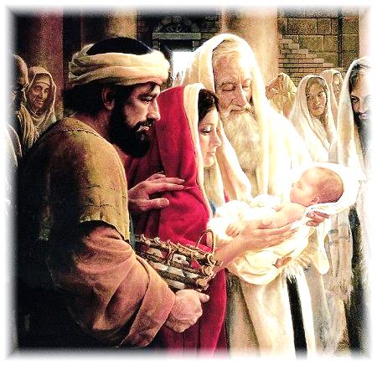
Luke 2:21–26 - And at the end of eight days, when he was circumcised, he was called Jesus, the name given by the angel before he was conceived in the womb. ²² And when the time came for their purification according to the Law of Moses, they brought him up to Jerusalem to present him to the Lord ²³ (as it is written in the Law of the Lord, “Every male who first opens the womb shall be called holy to the Lord”) ²⁴ and to offer a sacrifice according to what is said in the Law of the Lord, “a pair of turtledoves, or two young pigeons.” ²⁵ Now there was a man in Jerusalem, whose name was Simeon, and this man was righteous and devout, waiting for the consolation of Israel, and the Holy Spirit was upon him. ²⁶ And it had been revealed to him by the Holy Spirit that he would not see death before he had seen the Lord’s Christ.
The ____________ in the Temple
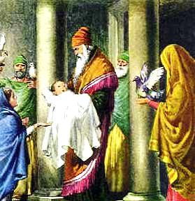
Luke 2:27–35 - And he came in the Spirit into the temple, and when the parents brought in the child Jesus, to do for him according to the custom of the Law, ²⁸ he took him up in his arms and blessed God and said, ²⁹ “Lord, now you are letting your servant depart in peace, according to your word; ³⁰ for my eyes have seen your salvation ³¹ that you have prepared in the presence of all peoples, ³² a light for revelation to the Gentiles, and for glory to your people Israel.” ³³ And his father and his mother marveled at what was said about him. ³⁴ And Simeon blessed them and said to Mary his mother, “Behold, this child is appointed for the fall and rising of many in Israel, and for a sign that is opposed ³⁵ (and a sword will pierce through your own soul also), so that thoughts from many hearts may be revealed.”
The ____________ in the Temple
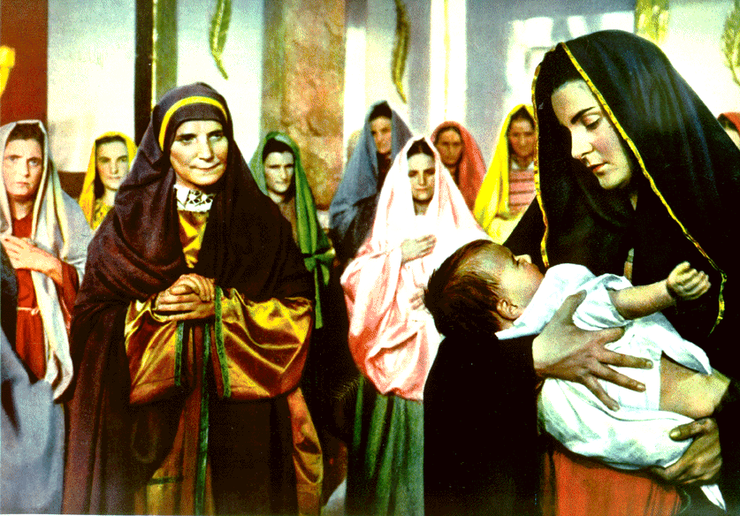
Luke 2:36–40 - And there was a prophetess, Anna, the daughter of Phanuel, of the tribe of Asher. She was advanced in years, having lived with her husband seven years from when she was a virgin, ³⁷ and then as a widow until she was eighty-four. She did not depart from the temple, worshiping with fasting and prayer night and day. ³⁸ And coming up at that very hour she began to give thanks to God and to speak of him to all who were waiting for the redemption of Jerusalem. ³⁹ And when they had performed everything according to the Law of the Lord, they returned into Galilee, to their own town of Nazareth. ⁴⁰ And the child grew and became strong, filled with wisdom. And the favor of God was upon him.

The ____________ in the Temple
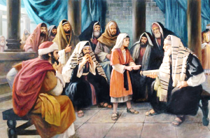 Luke 2:41–52 - Now his parents went to Jerusalem every year at the Feast of the Passover. ⁴² And when he was twelve years old, they went up according to custom. ⁴³ And when the feast was ended, as they were returning, the boy Jesus stayed behind in Jerusalem. His parents did not know it, ⁴⁴ but supposing him to be in the group they went a day’s journey, but then they began to search for him among their relatives and acquaintances, ⁴⁵ and when they did not find him, they returned to Jerusalem, searching for him. ⁴⁶ After three days they found him in the temple, sitting among the teachers, listening to them and asking them questions. ⁴⁷ And all who heard him were amazed at his understanding and his answers. ⁴⁸ And when his parents saw him, they were astonished. And his mother said to him, “Son, why have you treated us so? Behold, your father and I have been searching for you in great distress.” ⁴⁹ And he said to them, “Why were you looking for me? Did you not know that I must be in my Father’s house?” ⁵⁰ And they did not understand the saying that he spoke to them. ⁵¹ And he went down with them and came to Nazareth and was submissive to them. And his mother treasured up all these things in her heart. ⁵² And Jesus increased in wisdom and in stature and in favor with God and man.
Simple Gifts from Simply Christmas
The Prophet in the Temple
The Prophecy in the Temple
The Prophetess in the Temple
The Prophetic in the Temple
1. Though the religious system was imperfect, Jesus’ parents participated in it giving us a pattern regarding the imperfect church.
2. Jesus, as the light for the world and glory to Israel, is our message both now and always.
3. The first Advent of Jesus Christ was “hastened” because of the prayers of a faithful remnant. His Second Advent will be “hastened” by the same. “Even so come Lord Jesus in 2017!”
4. Jesus sets the example. He was always about His Father’s business. As His followers, we should do no less in the coming 12 months.
5. Jesus gives us a model for personal growth. We should all strive to grow physically, mentally, socially and spiritually in the New Year
