There was a ____________ of the Heavenly
Simply Christmas – Pt. 5
The Watching Shepherds in the Field
Luke 2:8-20
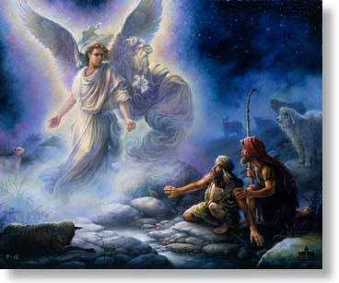
Luke 2:9-12 - And an angel of the Lord appeared to them, and the glory of the Lord shone around them, and they were filled with great fear. ¹⁰ And the angel said to them, “Fear not, for behold, I bring you good news of great joy that will be for all the people. ¹¹ For unto you is born this day in the city of David a Savior, who is Christ the Lord. ¹² And this will be a sign for you: you will find a baby wrapped in swaddling cloths and lying in a manger.”

Luke 2:8 - And in the same region there were shepherds out in the field, keeping watch over their flock by night.
There was a ____________ of the Heavenly
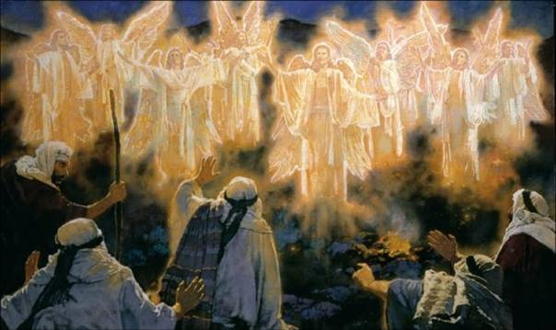
Luke 2:13-14 - And suddenly there was with the angel a multitude of the heavenly host praising God and saying, ¹⁴ “Glory to God in the highest, and on earth peace among those with whom he is pleased!”

There was a ____________ of the Heavenly
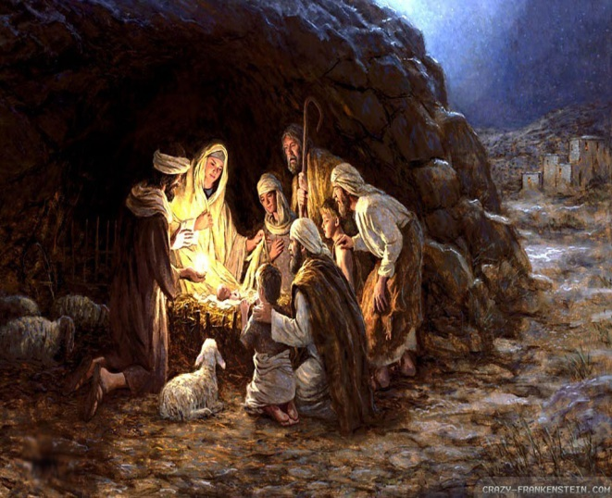
Luke 2:15-17 - When the angels went away from them into heaven, the shepherds said to one another, “Let us go over to Bethlehem and see this thing that has happened, which the Lord has made known to us.” ¹⁶ And they went with haste and found Mary and Joseph, and the baby lying in a manger. ¹⁷ And when they saw it, they made known the saying that had been told them concerning this child.

There was an ______________ of the Heavenly

Luke 2:18-20 - And all who heard it wondered at what the shepherds told them. ¹⁹ But Mary treasured up all these things, pondering them in her heart. ²⁰ And the shepherds returned, glorifying and praising God for all they had heard and seen, as it had been told them.

Simple Gifts from Simply Christmas
Declaration
Celebration
Revelation
Internalization
1. The “present” of this story is our gift as well. It is our gift this and every Christmas. It is the gospel, the Good News for all people.
2. The “person” of this story is our Savior as well. He is the Lord Jesus Christ.
3. The “praise” of this story is our celebration as well. We sing with the angels “Glory to God in the highest and peace on earth, good will to man”.
4. The “propagation” of this story is our spreading of the message as well. We are to make known the words about this Savior where ever we may find ourselves.
5. The “pondering” of the story is our contemplation as well. We wonder anew and reflect upon the amazing story of grace, mercy and love.


