“Where are the Nine?” - Luke 17:11-19
Context:

Luke 17:11 - On the way to Jerusalem he was passing along between Samaria and Galilee.

Luke 17:12 - And as he entered a village, he was met by ten lepers, who stood at a distance.

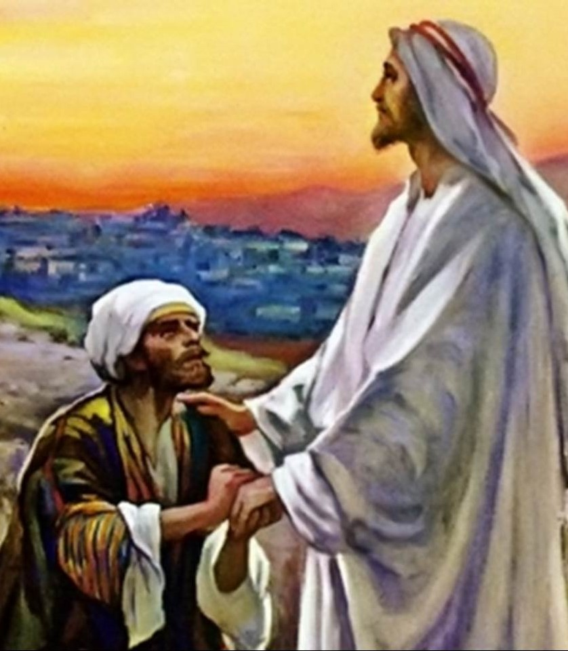

Luke 17:13 - And lifted up their voices, saying, “Jesus, Master, have mercy on us.”

Luke 17:14 - When he saw them he said to them, “Go and show yourselves to the priests.” And as they went they were cleansed.

Luke 17:19 - And he said to him, “Rise and go your way; your faith has made you well.”

Luke 17:15 - Then one of them, when he saw that he was healed, turned back, praising God with a loud voice…

Luke 17:16 - And he fell on his face at Jesus’ feet, giving him thanks. Now he was a Samaritan.

Luke 17:17 - Then Jesus answered, “Were not ten cleansed? Where are the nine?

Luke 17:18 - Was no one found to return and give praise to God except this foreigner?”

Three Interesting Trends in the Ministry of Jesus
#Samaritans – Luke 9:52-53, 10:33, 17:11, 16 & Acts 1:8
#Leprosy – Luke 4:27, 5:12-13, 7:22 & 17:12
#At His feet – Luke 8:35, 41, 10:39, & 17:16

What Are Today’s Take Aways?
Cultivating Gratitude in a Culture of Entitlement
1. Gratitude is cultivated when we fully embrace that God’s owes us exactly _____________. (Luke 17:10)
2. Gratitude is cultivated when we see that Jesus really cares about us, putting “________________________”. (Luke 17:11)
3, Gratitude is cultivated when we understand just what Jesus has ______________ us from. (Luke 17:12)
4. Gratitude is a cultivated when we grasp that God’s intervention in my life is an _____________ not a fulfillment of a debt. (Luke 17:13)
5. Gratitude is cultivated when we become less enamored with the gift and more focused on _________________. (Luke 17:14)
6. Gratitude is cultivated when we separate ourselves from the crowd we have been with and ______________ to Jesus. (Luke 17:15)
7. Gratitude is cultivated when we are willing to pay a price to praise the God who has given to us so much so ___________. (Luke 17:15)
8. Gratitude is cultivated when we are _________________________ in our praise to God. (Luke 17:16)
9. Gratitude is cultivated when we are willing to be in the _________, the 10%, as opposed to the majority, the 90%. (Luke 17:17-18)
10. Gratitude is cultivated when we see it as a work that accompanies our faith, it’s part of being a ________________. (Luke 17:19)
“Where are the Nine?”
Luke 17:11-19

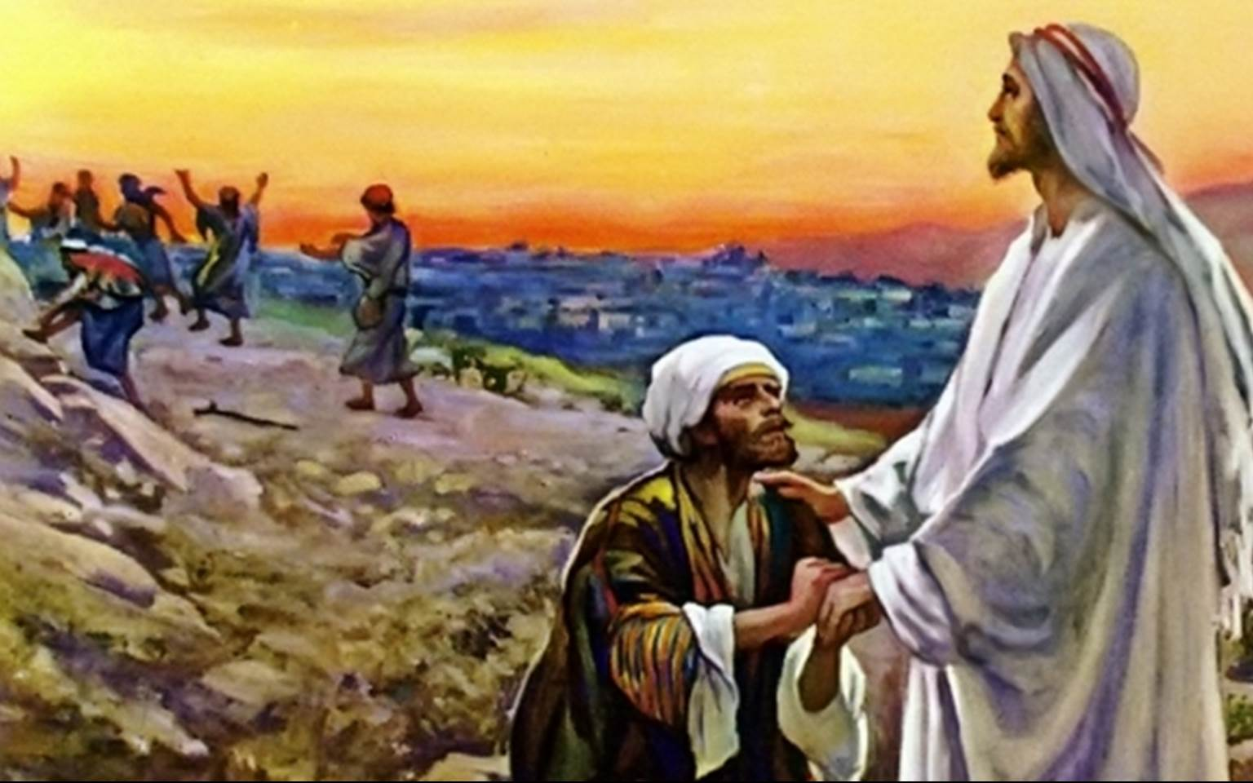

Presented by Pastor Dave Watson
at Calvary Chapel

