The Stars of Christmas
Gabe and His Posse
Opening Words
A. The _________________
1. Gabriel - “God is great — an Archangel who acts as the messenger of God; he appeared to Daniel (Dan. 8:16), Zacharias (Luke 1:19), and the Virgin Mary (Luke 1:26–38). All appearances of Gabriel recorded in the Bible are connected with the promise about the coming of the Messiah. But one passage may link Gabriel with Christ’s return. In Christian tradition, Gabriel is sometimes identified as the archangel whose voice is heard at the Second Coming of Christ (1 Thess. 4:16). Although Gabriel is not mentioned by name in this passage, he is sometimes depicted as the trumpeter of the Last Judgment.” – The New Illustrated Nelson’s Bible Dictionary
Luke 1:19a - And the angel answered him, “I am Gabriel. I stand in the presence of God…..
Luke 1:26a - In the sixth month the angel Gabriel was sent from God…
2. The angel of the Lord
Luke 2:8–9 - And in the same region there were shepherds out in the field, keeping watch over their flock by night. ⁹ And an angel of the Lord appeared to them, and the glory of the Lord shone around them, and they were filled with great fear.
Matthew 1:20 - But as he considered these things, behold, an angel of the Lord appeared to him in a dream, saying, “Joseph, son of David, do not fear to take Mary as your wife, for that which is conceived in her is from the Holy Spirit. – See also Matthew 2:13 & 19

B. The _________________
1. They are ministers of God
Hebrews 1:7 - Of the angels he says, “He makes his angels winds, and his ministers a flame of fire.”
2. They are ministers to us
Hebrews 1:14 - Are they not all ministering spirits sent out to serve for the sake of those who are to inherit salvation?
C. The _________________
1. Fear not – Trust in the _________________ to God
Luke 1:13 - But the angel said to him, “Do not be afraid, Zechariah, for your prayer has been heard, and your wife Elizabeth will bear you a son, and you shall call his name John.
2. Fear not – Trust in the __________________ of God
Luke 1:30–31, 34 & 37 - And the angel said to her, “Do not be afraid, Mary, for you have found favor with God. ³¹ And behold, you will conceive in your womb and bear a son, and you shall call his name Jesus….” And Mary said to the angel, “How will this be, since I am a virgin?” … For nothing will be impossible with God.”
3. Fear not – Trust in the _______________ by God
Matthew 1:20–21, 24-25 - But as he considered these things, behold, an angel of the Lord appeared to him in a dream, saying, “Joseph, son of David, do not fear to take Mary as your wife, for that which is conceived in her is from the Holy Spirit. ²¹ She will bear a son, and you shall call his name Jesus, for he will save his people from their sins.”… When Joseph woke from sleep, he did as the angel of the Lord commanded him: he took his wife, ²⁵ but knew her not until she had given birth to a son. And he called his name Jesus.
4. Fear not – Trust in the __________________ from God
Luke 2:10–11 - And the angel said to them, “Fear not, for behold, I bring you good news of great joy that will be for all the people. ¹¹ For unto you is born this day in the city of David a Savior, who is Christ the Lord.
D. The __________________________
1. The angels ______________
Luke 1:19 - And the angel answered him, “I am Gabriel. I stand in the presence of God, and I was sent to speak to you and to bring you this good news.
Luke 1:26 - In the sixth month the angel Gabriel was sent from God to a city of Galilee named Nazareth…
2. The angels _______________
Matthew 1:21 - She will bear a son, and you shall call his name Jesus, for he will save his people from their sins.”
Luke 2:11 - For unto you is born this day in the city of David a Savior, who is Christ the Lord.
3. The angels __________________
Luke 2:13–14 - ¹³ And suddenly there was with the angel a multitude of the heavenly host praising God and saying, ¹⁴ “Glory to God in the highest, and on earth peace among those with whom he is pleased!”
Hebrews 1:6 - And again, when he brings the firstborn into the world, he says, “Let all God’s angels worship him.”
So…What’s it to me

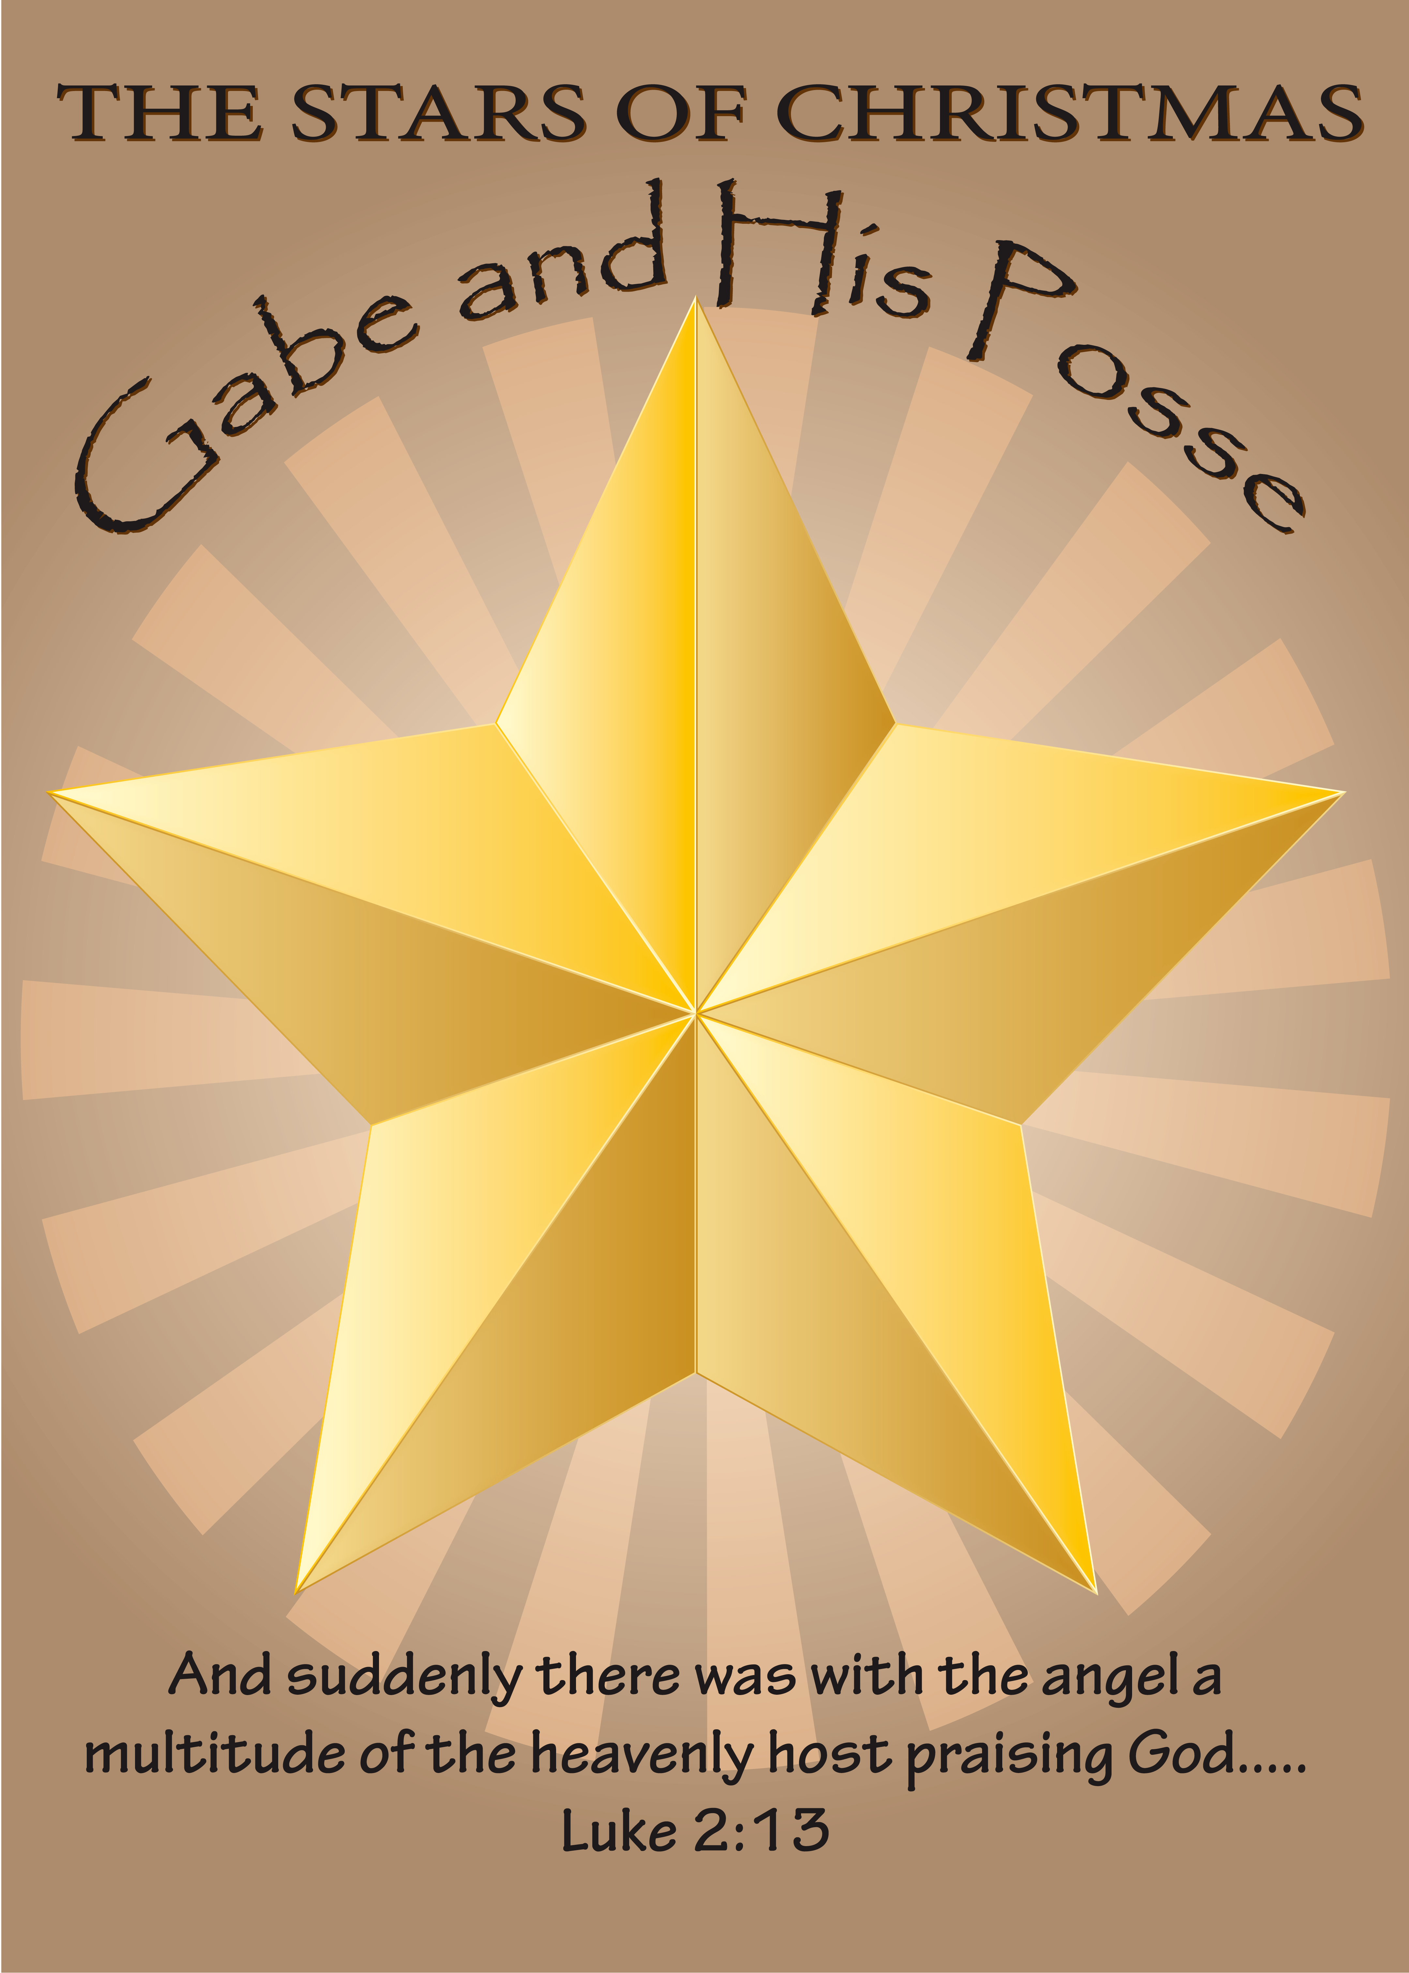
Presented by Pastor Dave Watson
at Calvary Chapel

