Do the Math – What does it take to be a follower of Christ?
Selected – The Gospel of Luke

Being a follower of Christ is defined as:
1. Being a _________

2. Being a __________

3. Being a ___________

Being a follower of Jesus Christ means:
1. I must be willing to ____________ my _________
Luke 9:23-27 - And he said to all, “If anyone would come after me, let him deny himself and take up his cross daily and follow me. ²⁴ For whoever would save his life will lose it, but whoever loses his life for my sake will save it. ²⁵ For what does it profit a man if he gains the whole world and loses or forfeits himself? ²⁶ For whoever is ashamed of me and of my words, of him will the Son of Man be ashamed when he comes in his glory and the glory of the Father and of the holy angels. ²⁷ But I tell you truly, there are some standing here who will not taste death until they see the kingdom of God.”

2. I must first _________ the ________
Luke 14:25-33 - Now great crowds accompanied him, and he turned and said to them, ²⁶ “If anyone comes to me and does not hate his own father and mother and wife and children and brothers and sisters, yes, and even his own life, he cannot be my disciple. ²⁷ Whoever does not bear his own cross and come after me cannot be my disciple. ²⁸ For which of you, desiring to build a tower, does not first sit down and count the cost, whether he has enough to complete it? ²⁹ Otherwise, when he has laid a foundation and is not able to finish, all who see it begin to mock him, ³⁰ saying, ‘This man began to build and was not able to finish.’ ³¹ Or what king, going out to encounter another king in war, will not sit down first and deliberate whether he is able with ten thousand to meet him who comes against him with twenty thousand? ³² And if not, while the other is yet a great way off, he sends a delegation and asks for terms of peace. ³³ So therefore, any one of you who does not renounce all that he has cannot be my disciple.

3. I must unconditionally _______ the ___________
Luke 9:57-62 - As they were going along the road, someone said to him, “I will follow you wherever you go.” ⁵⁸ And Jesus said to him, “Foxes have holes, and birds of the air have nests, but the Son of Man has nowhere to lay his head.” ⁵⁹ To another he said, “Follow me.” But he said, “Lord, let me first go and bury my father.” ⁶⁰ And Jesus said to him, “Leave the dead to bury their own dead. But as for you, go and proclaim the kingdom of God.” ⁶¹ Yet another said, “I will follow you, Lord, but let me first say farewell to those at my home.” ⁶² Jesus said to him, “No one who puts his hand to the plow and looks back is fit for the kingdom of God.”

Being a follower of Jesus Christ involves:
1. An _________ – I have _____________ Jesus Christ

2. A _________ – I am _________________ to Jesus Christ

3. A __________ – I am _________________ Jesus Christ

Today’s take Aways

Doing the Math
What does it take to be a follower of Christ?
Selected – The Gospel of Luke

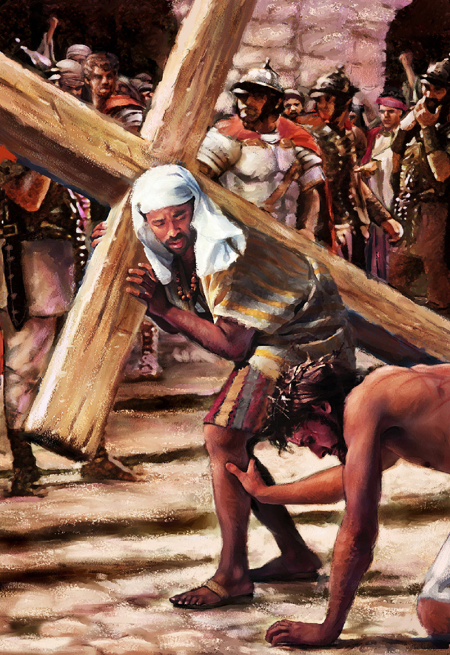
Presented by Pastor Dave Watson
at Calvary Chapel

