Today’s Take Aways
From the Context
It is a time of prayer

It is a time of preparation

It is a time of promise

From the Characters
Jesus

Moses and Elijah

Peter, James and John

From the Command
This my Son, the Chosen One

Listen to Him

The People We Meet on the
Journey to the Cross – Pt. 1
Moses & Elijah
on the Mount of Transfiguration
Luke 9:28-36

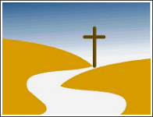

Presented by Pastor Dave Watson
At Calvary Chapel

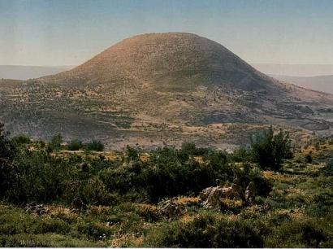
The Setting - Luke 9:28, 37 & 51 - Now about eight days after these sayings he took with him Peter and John and James and went up on the mountain to pray…On the next day, when they had come down from the mountain, a great crowd met him…When the days drew near for him to be taken up, he set his face to go to Jerusalem.

The People We Meet on the Journey to the Cross – Pt. 1
Moses & Elijah on the Mount of Transfiguration
Luke 9:28-36
“In the time of Jesus the mount of transfiguration was on the way to the cross. In our day the cross is on the way to the mount of transfiguration. If you would be on the mountain, you must consent to pass over the road to it.” ― Henry Clay Trumbull
Scene #4 - Personalization
Luke 9:36 - And when the voice had spoken, Jesus was found alone. And they kept silent and told no one in those days anything of what they had seen.
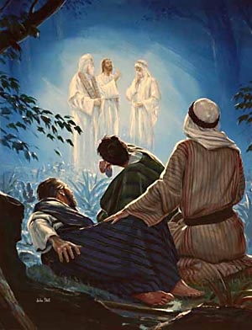
Scene 3 - Declaration
Luke 9:34-35 - As he was saying these things, a cloud came and overshadowed them, and they were afraid as they entered the cloud. ³⁵ And a voice came out of the cloud, saying, “This is my Son, my Chosen One; listen to him!”
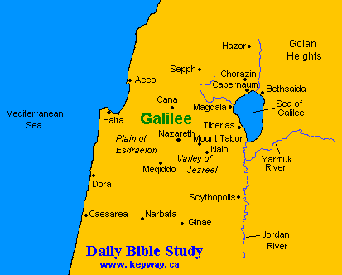
Scene #1 – Transformation
Luke 9:29-31 - And as he was praying, the appearance of his face was altered, and his clothing became dazzling white. ³⁰ And behold, two men were talking with him, Moses and Elijah, ³¹ who appeared in glory and spoke of his departure, which he was about to accomplish at Jerusalem.
Scene #2 – Misinterpretation
Luke 9:32-33 - Now Peter and those who were with him were heavy with sleep, but when they became fully awake they saw his glory and the two men who stood with him. ³³ And as the men were parting from him, Peter said to Jesus, “Master, it is good that we are here. Let us make three tents, one for you and one for Moses and one for Elijah”—not knowing what he said.

