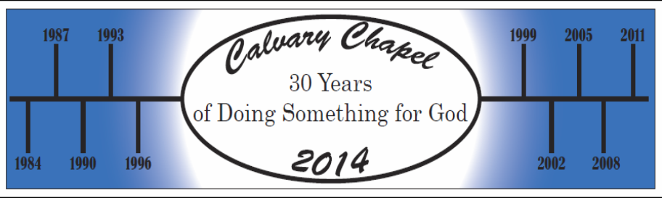
1. The ___________ for our service to our God – Hebrews 11:1-12:2 - An athletic contest in a stadium for the citizens of the kingdom

Get on the __________
2. The ________ for our service to our God – Hebrews 12:1 a - ..since we are surrounded by so great a cloud of witnesses……

Enter the _________
3. The _________ for our service to our God – Hebrews 12:1b - ….let us also lay aside every weight, and sin which clings so closely

Lose the _____________
4. The ___________ for our service to our God – Hebrews 12:1c - … and let us run …..the race that is set before us….

Run your ___________
5. The __________ for our service to our God – Hebrews 12:1a&d - Therefore…..with endurance….

Play though the _________
6. The _________ for our service to our God – Hebrews 12:2 - …..looking to Jesus, the founder and perfecter of our faith, who for the joy that was set before him endured the cross, despising the shame, and is seated at the right hand of the throne of God.

Focus on the ___________

7. The __________ for our service to our God – Hebrews 12:1-2 - Therefore, since we are surrounded by so great a cloud of witnesses, let us also lay aside every weight, and sin which clings so closely, and let us run with endurance the race that is set before us, ² looking to Jesus, the founder and perfecter of our faith, who for the joy that was set before him endured the cross, despising the shame, and is seated at the right hand of the throne of God.

Pass the ____________
Today’s take away for me are…………..

